How to get the function module name of a previously executed smartform.

1. Go to Tcode SMARTFORM and enter the name of the smartform and then click on SMART FORMS tab on the application task bar. Click on Test.

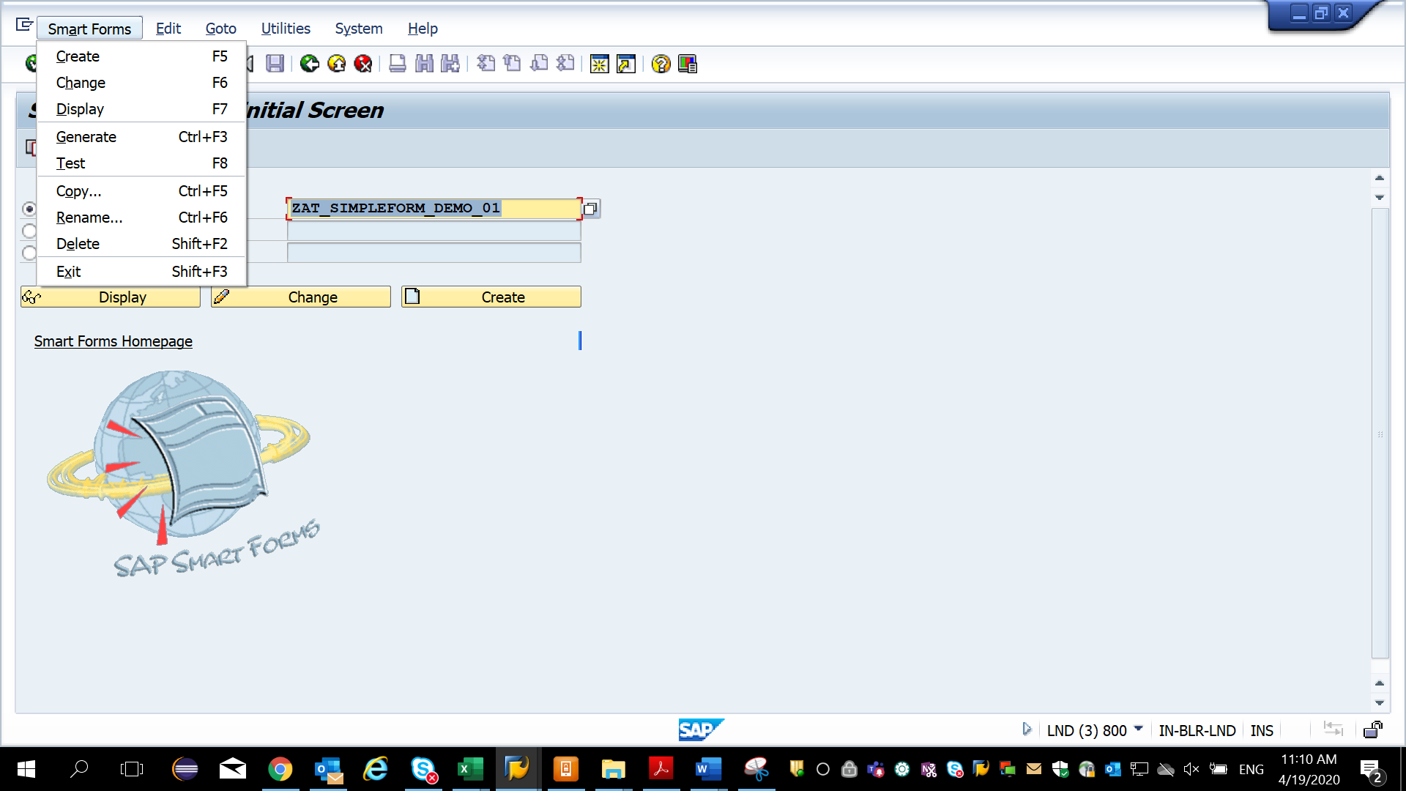

You get the function module screen as below:

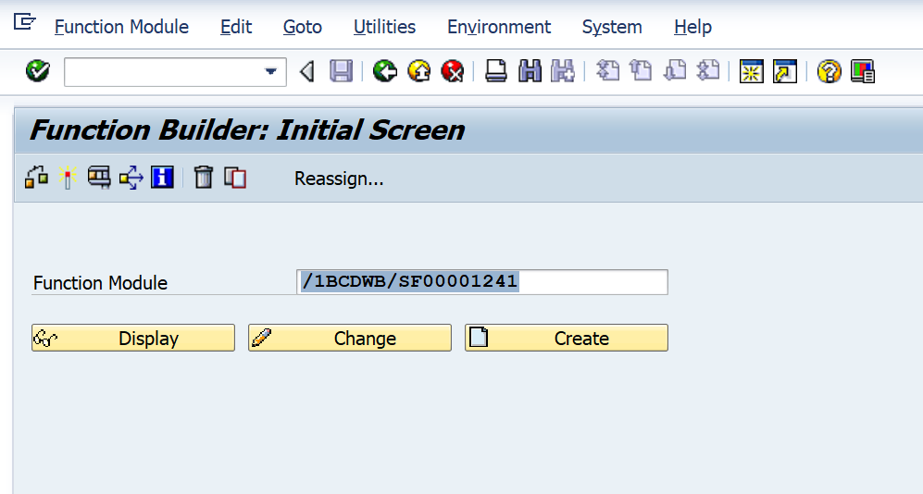

OR

1) Click on Change in the smartforms screen and go into the smartform

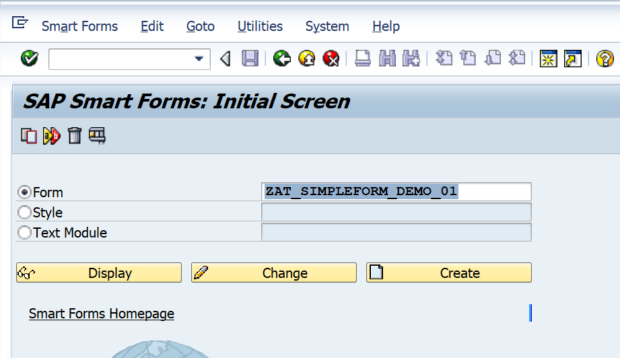

1. And then click on Environment tab to get the function module.

